Setup explanation:

1. for database I add one more column for titile table, poster, store the image link for UI use.

Backend:

I choose ,net core api for backend, it’s easier for set up and doing dependency injection.

Structure I use onion architecture, 4 layer: model, repository, service and application.

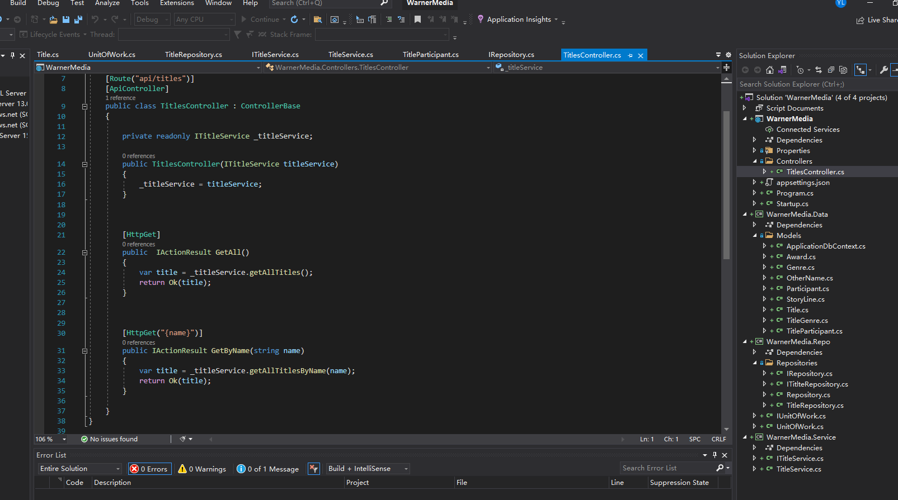

Also implement unit of work so each time for a endpoint request we only have one database instance.

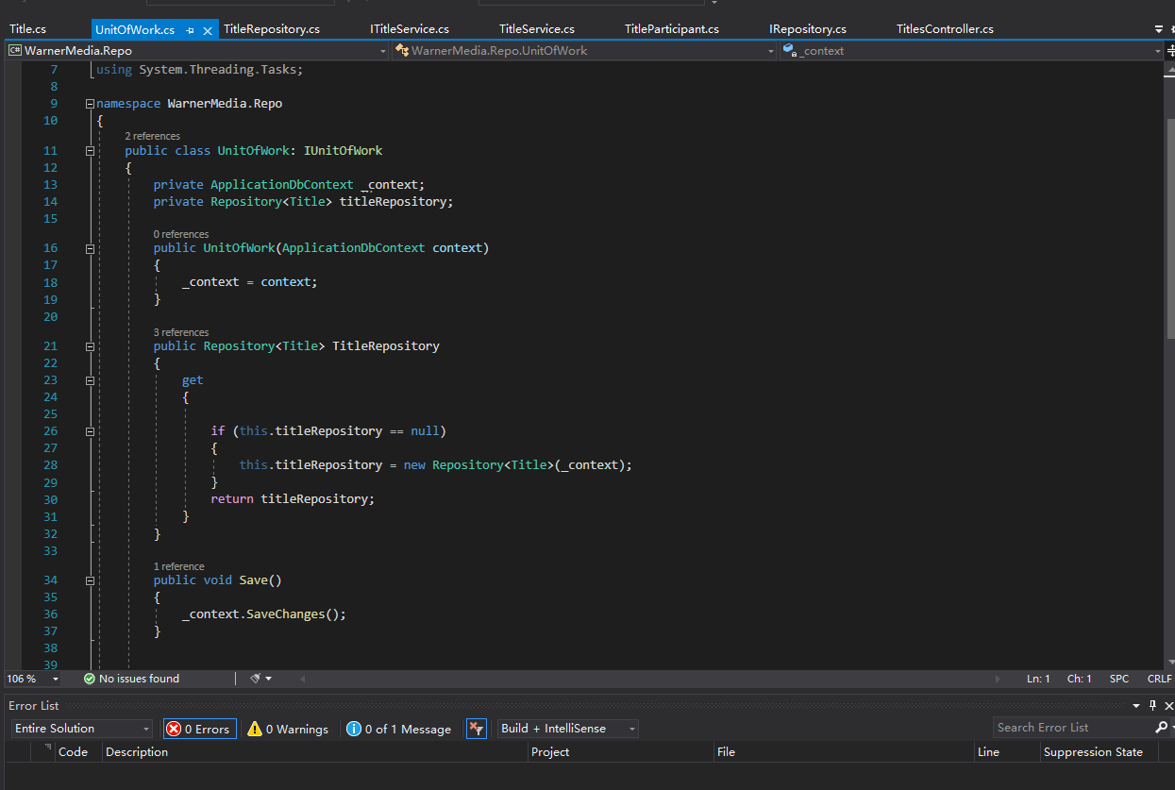

We can see successfully get data back

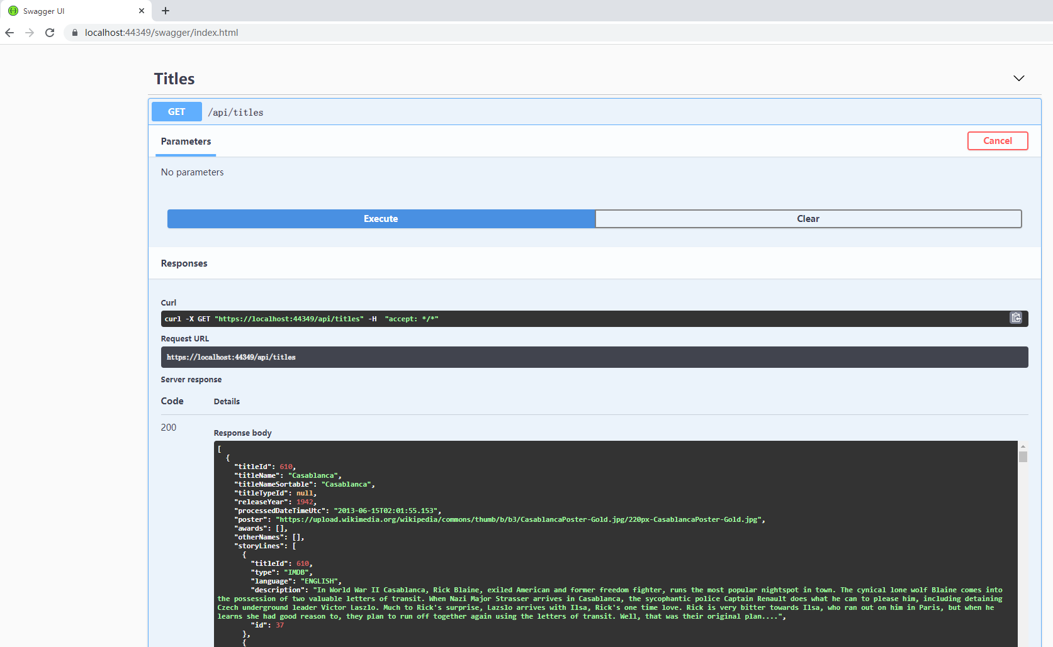

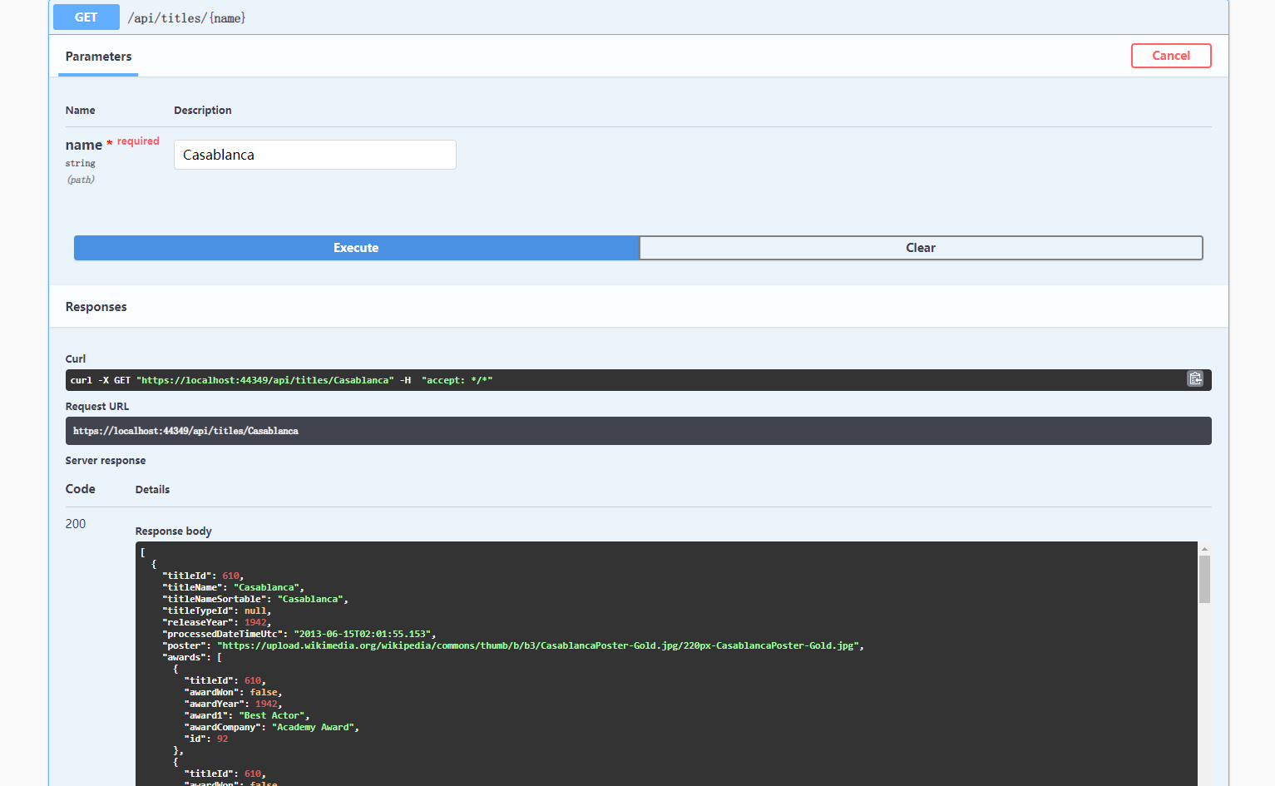

Two endpoint, one getall title details. One get title detail data by input.

Front-end:

Using latest version react:

Separate to several components, also implement router.(here mainly two routes, one is main page, one is detail page.

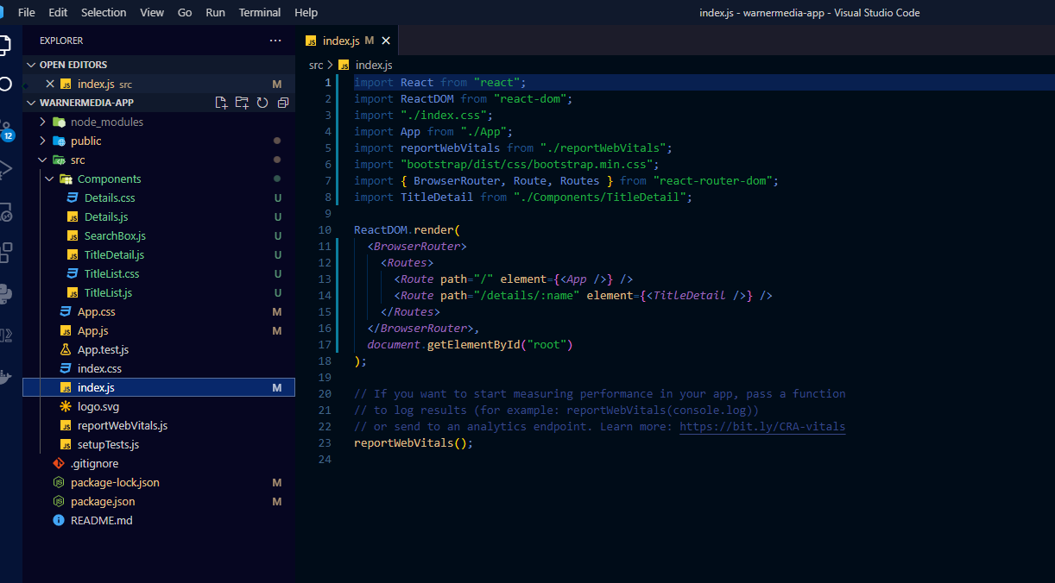

Application is not big so not set up very detail components folder.

By using usetate, useeffect hook and other basic pass value ,method fulfill the requirements.

Main page:

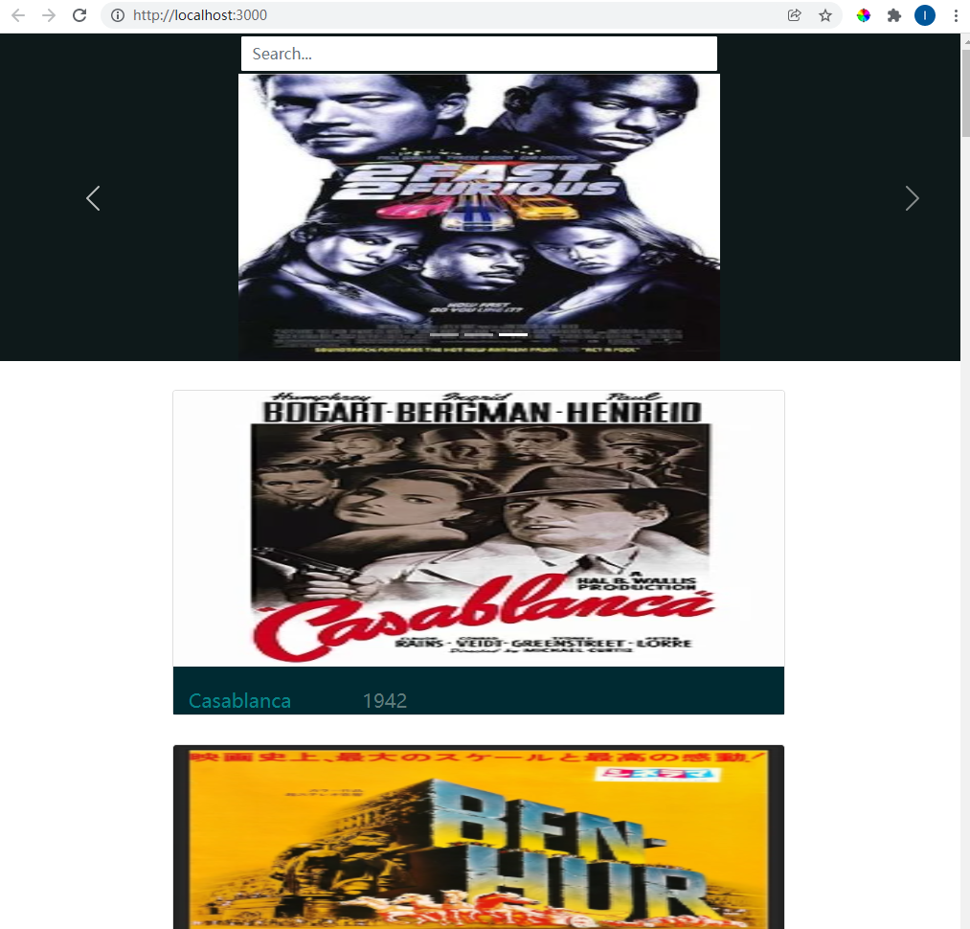

Sample detail page:

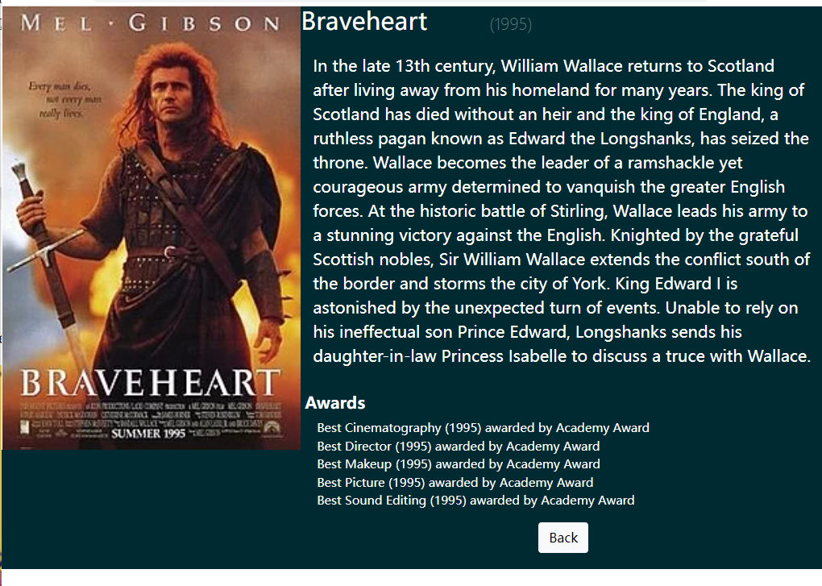



Here also from main page can do search, filter by input, will show through a short video.